Development and Setup of an Inline Holography System

The aim of the workshop is to discover the wave nature of light and to build a compact microscope that makes use of light's ability to interfere. The workshop teaches how a complex three-dimensional part can be created with a few steps using 3D printing, which then serves as the basis for the electronic components with which the microscope is to be built.

The biological aspect of this workshop will stimulate the creativity of the participants* to find their own samples, prepare them and image them with the microscope. The digital reconstruction of the hologram will be done using open source software tools such as Python and OpenCV.

Benedict Diederich

V0; 24.8.2018

V1; 13.01.2018

Translated by DeepL.com

## Inhaltsverzeichnis

Inhaltsverzeichnis 2

Motivation 4

Advantages over classical Microscopy 4

Goals 5

Structure of the microscope (practical part) 6

FINISHED CONSTRUCTION 6

Partlist 7

Software 8

Preparing the Raspberry Pi 9

Design and printing of necessary parts 9

Konstruktion der 3D Teile mit Tinkercad 10

Konstruktion: Pinhole-Adapter 11

Konstruktion: Pinhole-Adapter 12

Konstruktion: Objekthalter + Kameraadapter 13

3D Druck: Exportieren und anfertigen des Drucks 13

Ansteuerung der Power-LED 14

Anfertigen der Lochblende/des Pinhols 15

Theory Part 16

What is light? 16

What is coherence? 17

Holography 19

Fundamentals 19

RECORDING 19

APPENDIX 27

Recording with Raspi camera 27

The sensor is very sensitive, the software allows a simple control of the shooting parameters (exposure time, etc.), as well as the storage and output of captured images. The new version (V2.1) is based on a Sony IM135 sensor, which can also be found in mid-range smartphones. 27

Please note that the lens must be removed from the camera model. The normally corrected shading correction, which compensates for lens errors, now overcompensates the images, resulting in a bright edge. 27

RECORDING HOLOGRAMS 27

Recording with M5Stack Camera 28

SAMPLE PREPARATION 29

Useful links and sources 29

Publications 29

Hilfreiche Links 31

## Motivation

* Imaging without lenses? How does it work?
* Development of a cost-effective microscope e.g. for use in developing countries
* How can a hologram be digitally reconstructed and refocused?
* What does interference of light mean?
* Microscope based on available components (cheap/open source)
* Detection whether e.g. malaria is infected

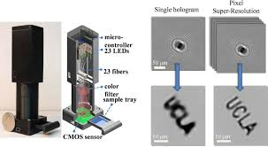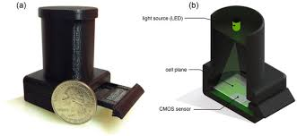

Greenbaum, A., Akbari, N., Feizi, A., Luo, W., & Ozcan, A. (2013). Field-Portable Pixel Super-Resolution Colour Microscope. *PLoS ONE*, *8*(9), 1–9.

## Advantages over classical Microscopy

* No expensive optics, which may aberrate the object
* Cheap (Webcam < 100€; or Smartphone+DLP < 200€)
* High resolution (pixel dependent, "Subpixel Superresolution")
* Large field of view (= sensor size)
* Portable and robust
* Due to different lighting patterns possibly different shooting modes possible:
* Digital phase contrast, DIC, etc. (Z-Propagation, Focus Through Method) possible

Goals  
At the end of the workshop, the participants* will be able to

* To describe the wave behaviour of light
* Know the basics of holography
* Develop a concept that represents the prototype for a lensless microscope
* Designing a CAD part.
* ... and to manufacture the CAD part using a 3D printer.
* A simple electronic circuit to solder
* A simple program to write what a camera image takes with the Raspberry Pi
* A simple program to write what reconstructs the camera image on the Raspberry Pi
* Putting the prototype into operation and testing it
* Evaluate your work

# Structure of the microscope (practical part)

In the following, we will briefly explain what the individual components are used for and how they relate to each other. At the end a digital-holographic microscope is to be developed, which can be built completely.

# FINISHED CONSTRUCTION

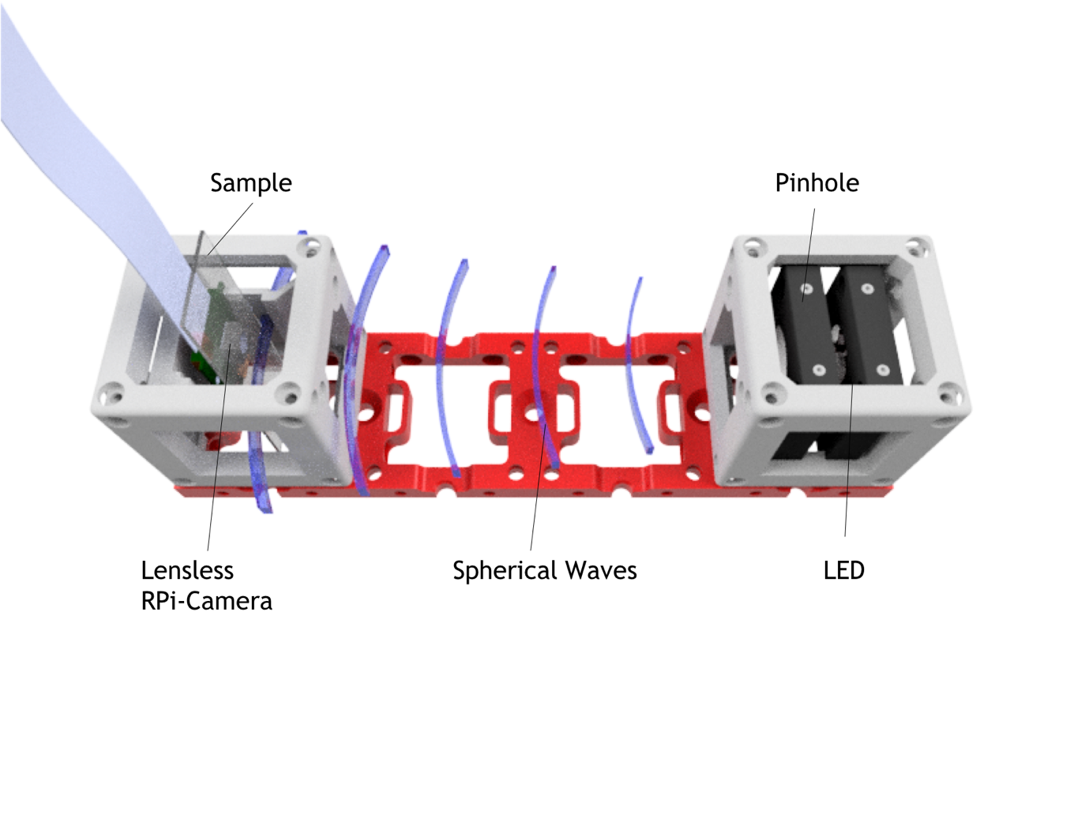

Figure 1 - This is what the finished microscope looks like when all parts come together. The blue lines represent the spherical waves emanating from the pinhole.

## Partlist

|  |  |  |  |
| --- | --- | --- | --- |
| Anzahl | Bezeichnung | Bild | Preis |
| 1 | Grundplatte (1x4)   * <https://github.com/bionanoimaging/UC2-GIT/blob/master/CAD/INLINE_HOLOGRAM/STL/INLINE_HOLOGRAM_00_Base_4x1_v0.stl> |  | 1€ |
| 2 | Cube (2x), 2 Teile   * <https://github.com/bionanoimaging/UC2-GIT/blob/master/CAD/INLINE_HOLOGRAM/STL/INLINE_HOLOGRAM_10_Cube_v0.stl> * <https://github.com/bionanoimaging/UC2-GIT/blob/master/CAD/INLINE_HOLOGRAM/STL/INLINE_HOLOGRAM_10_Lid_el_v0.stl> |  | 1€ |
| 1 | LED (Royal blue, i.e. 1W-3W, Star PCB attached)   * <https://www.amazon.com/Led-World-Extreme-Royal-445-450nm/dp/B00MNB4LJU> |  | 2€ |
| 1 | RPi Camera v2   * <https://shop.pimoroni.de/products/raspberry-pi-camera-module-v2-1-with-mount>   Alternative für Pi Zero:   * <https://shop.pimoroni.de/products/raspberry-pi-zero-camera-module> |  | 15€-33€ |
| 1 | Raspberry Pi V3 + 1SD Micro Card (prebuilt binaries)   * <https://shop.pimoroni.de/products/raspberry-pi-3-b-plus>   Alternativ:  1x Raspberry Pi Zero + 1SD Micro Card (8GB)   * <https://shop.pimoroni.de/products/raspberry-pi-zero-w> | /var/folders/4w/k4yhf14j7xsbp2jd85yk555r0000gn/T/com.microsoft.Word/Content.MSO/45DC5D6D.tmp | 45€  /  15 € |
| 2 | Thorlabs CP02   * <https://www.thorlabs.com/thorproduct.cfm?partnumber=CP02>   Alternative:  Selber drucken |  | 20€ |
| 1 | Netzteil, 5V USB, Raspberry   * <https://www.reichelt.de/usb-ladegeraet-5-v-2500-ma-micro-usb-nt-musb-25-sw-p167078.html?PROVID=2788&gclid=Cj0KCQjw3ebdBRC1ARIsAD8U0V5RBH3hKsPJiLh7Pk8SBP6UYqJqPXgTA_QfsG1lmuD5Y75ie5qSEMIaAiNCEALw_wcB&&r=1> |  | 5€ |
|  | Zusätzliches Material, was ggf. bereits verfügbar ist.   * Alufolie * Alumnium Sheet ca. 30x30 mm, rund? (dickere Aluminium Folie) * Dünne Nadel * Klebestreifen * USB-Stick * Tastatur/Maus |  | 10€ |
| 16 | Kugelmagneten NeoDym, D=6mm   * <https://www.ebay.de/itm/50x-POWER-NEODYM-KUGEL-MAGNET-6-mm-N35-EXPERIMENT-BASTEL-TAFEL/201693302926?hash=item2ef5db908e:g:QgUAAOSwpLNYBJt7> |  | 10€ |
| 16 | Schrauben (DIN 912, M3, 18mm, kein Edelstahl! Müssen magnetisch sein-> Eisen!)   * <https://www.conrad.de/de/toolcraft-839670-zylinderschrauben-m3-12-mm-innensechskant-din-912-iso-4762-stahl-88-geschwaerzt-100-st-839670.html> |  | 1€ |
| 4 | Alu-Stangen (50mmxD6mm)   * <https://www.ebay.de/itm/7960-Alu-Aluminium-Rundstab-6-12mm/321920077077?hash=item4af3ee8d15:m:m6S16XrMjjoQHAna_7z12Ug> |  | 4 € |
| 1 | 100R Widerstand, 1W, oder 4x 400R 0.25W parallel |  | 1 € |
| 1 | (USB) Kabel (defektes Gerät, Schrott), ca. 40cm |  | 1 € |
|  |  |  |  |
|  |  |  |  |
| 1 | Proben: Duschgel mit Glitzereffekt, Mikrokugeln, Epithelzellen |  |  |
| 1 | Probenpräparationskit,  Pipette, Deckgläschen, Objektträger (120x70mm)  <https://www.msg-praxisbedarf.de/MENZEL-Objekttraeger-MIT-Mattrand-50-Stueck.htm?websale8=msg&pi=58150&ref=froogle&subref=MEG101126M&gclid=Cj0KCQjw3ebdBRC1ARIsAD8U0V5Luk5NOQ_5EgCx-r_ZP_9B5Slwe-cPsXAOKK-Mx73bsF8DHiD24gEaArfkEALw_wcB> |  | 5€ |

Software

* Fiji (<https://imagej.net/Fiji/Downloads>)
* Fiji Plugin und Python Code (<https://github.com/bionanoimaging/UC2-GIT/tree/master/WORKSHOP/INLINE-HOLOGRAMM>)
* Anaconda Python (3.6) ( <https://www.anaconda.com/download>)
* Cura (<https://ultimaker.com/en/products/ultimaker-cura-software>)
* Tinkercad.com

## Preparing the Raspberry Pi

We have prepared an installation script which simplifies your work enormously. You can find the link with all important information here:

- <https://github.com/bionanoimaging/UC2-GIT/tree/master/RASPBERRY-PI>

## Design and printing of necessary parts

The microscope is based on a simple wave optical phenomenon of light. We have an LED that serves as a light source. Directly behind this source follows a very small pinhole. This pinhole prevents the light from propagating in free space (e.g. air) everywhere except the small opening in the center of the foil. According to the hygenic principle, spherical waves with the radius of the wavelength of the light are formed here very similar to a water wave that passes through a thin slit.

This spherical wave propagates over a certain distance, which corresponds to the radius of the sphere. This is compared to the wavelength (e.g. 450 nm) with e.g. 100 mm (100,000,000 nm), which means that the once spherical wave is now almost flat. This (almost) flat wave hits a semi-transparent object (e.g. microscopic thin section) and is scattered at the structure of the object. This means that the light is refracted, diffracted and reflected. Similar to the small opening in the center of the foil, many small spherical waves form. These many spherical waves go again in all directions and thus also in the direction of the camera sensor, which lies directly behind the object.

The (almost) flat wave also propagates further in the direction of the sensor and interferes with the many small spherical waves of the object on the sensor. The analogy with water also works here. Water waves coming from two directions running in each other add up and can for example form an even bigger wave.

The workshop is based on the optical modular system You-See-Too (UC2), which ensures a simple and precise arrangement of the components. The system is so flexible that missing components can be easily installed. The missing components to be built during the workshop include:

1. a holder for the LED (3D printed)
2. a holder for the pinhole (3D printed)
3. a holder for the object (3D printed)
4. the aperture itself
5. electronic circuit for the LED (soldered)

## Construction of 3D parts with Tinkercad

The construction of the 3D objects will be done with the online design tool "Tinkercad" from Autodesk. For this a user account must be created. The correct indication of name, email, etc. is not necessary, if one does not need the parts later again (fantasy values can be used).

The parts 1-3 can be created in a so-called component.

Introduction: Follow the tutorial of Tinkercad. 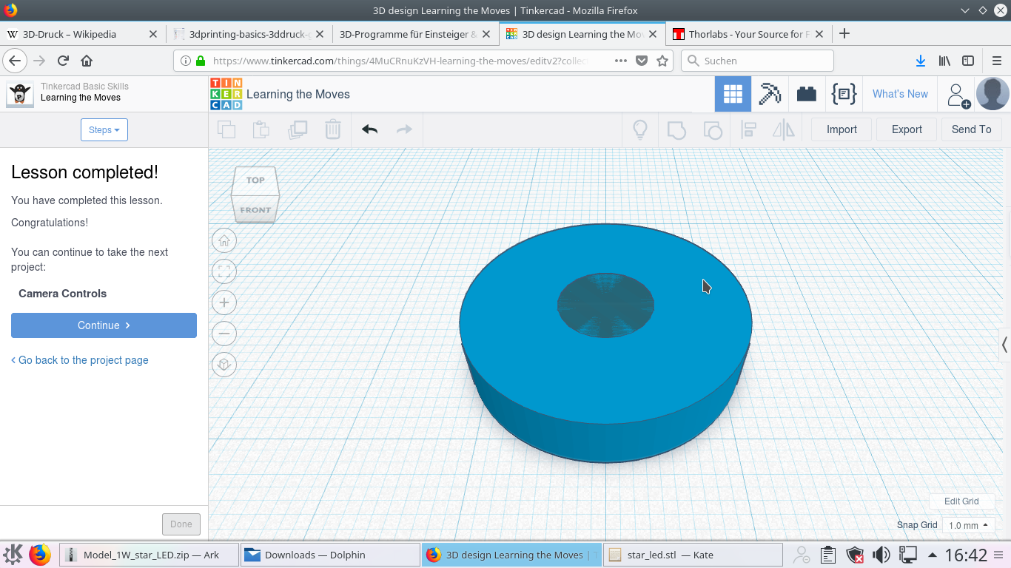

Abbildung 1: Rahmen für das Pinhole in Tinkercad

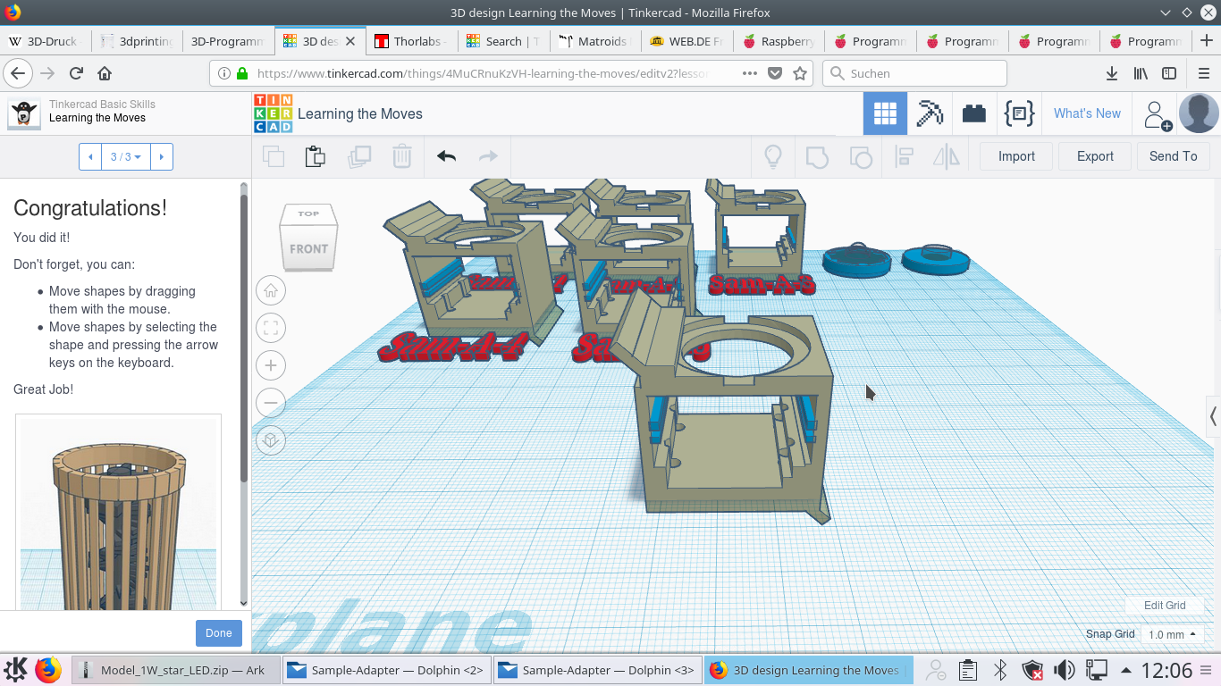

Abbildung 2: Finaler Sample Adapter in Tinkercad

### Konstruktion: Pinhole-Adapter

Die Lochblende wird mithilfe einer Nadel aus Aluminium herausgestochen. Die Alufolie kann mit doppelseitigem Klebeband auf einem gedruckten Rahmen gefestigt werden. Dieser Rahmen soll in das sogennante Cage-System von Thorlabs (CP02) passen. Die Abmaße von diesem Cage sind unten zu finden:

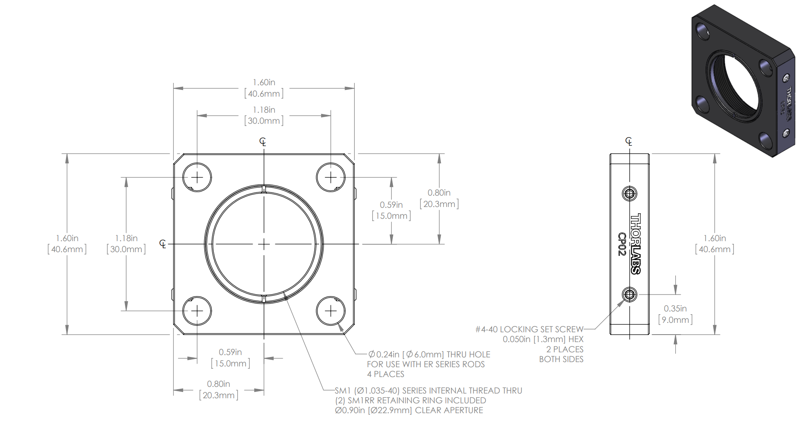

Die Thorlabshalterung hat ein Gewinde im inneren des Korpus. Zwei Ringe ausgestattet mit einem Gewinde können den Rahmen für die Alufolie fixieren.

Der Rahmen könnte also z.B. so aussehen: 

### CONSTRUCTION: PINHOLE ADAPTER

The pinhole diaphragm is pierced out of aluminium using a needle. The aluminium foil can be fixed to a printed frame with double-sided adhesive tape. This frame should fit into the Thorlabs Cage System (CP02). The dimensions of this cage can be found below:

The Thorlabs mount has a thread inside the body. Two rings equipped with a thread can fix the frame for the aluminium foil.

The frame could look like this:



The LED follows directly behind the pinhole. Both can be mounted one after the other in one of the cubes. The Thorlabs cage system can be brought together using rods.

The frame, or holder for the LED, can be similar to the pinhole. The power LED with "STAR" board should then be glued to this 3D printed element with hot glue.

A possible variant could look like this:

### CONSTRUCTION: OBJECT HOLDER + CAMERA ADAPTER

The object must hang as close as possible to the camera chip so that the short coherence length of the system can also be used for the interference effects (more on this later). The camera adapter for the Raspberry-Pi camera, which is intended for the Cube, is already ready and should only be extended by the function of the sample holder.

The samples (e.g. mucous membrane cells from the mouth) can be placed on a microscope slide with the following dimensions

***Glass slides: (WxHxD) 24x70x1 mm***

can be made. The task now is to extend the camera adapter so that a slide can be inserted. This could look like this:



### 3D PRINT: EXPORT AND MAKE THE PRINT

In Tinkercad there is the option to export the individual parts as STL files. For this you can mark a single part and download it from the browser window. These STL files can then be inserted into the 3D printing software (e.g. Cura), arranged and exported to an SD card for 3D printing. The printing time for all parts takes about 1 hour per participant.

Parameters for printing:

* Material: ABS (Black is best because light is absorbed)
* Layerheight: 0.1-0.15 mm
* Support structure: Off
* nozzle: 0.25-0.4mm
* Prints have been made on an Ultimaker 2+ and Be3D DeeGreen so far.Parameter für den Druck:

### POWER-LED CONTROL

A power LED (Light EMitting Diode) will be used as a light source in this workshop. This semiconductor consisting of a so-called PN-junction is able to convert electrons into photons. It is important to note the polarity, i.e. +/- of the connections. Furthermore the operating voltage and the operating current have to be considered for a correct function. If this does not happen, the LED overheats and breaks down.

For the simple use of the element we use a USB power supply, which delivers by definition approx. 5V and 1A. The LED needs a voltage of approx. 2.5 V at approx. 100mA current. Thus a series resistor is necessary, which reduces the "excess" power, in order to adjust the operating point of the LED. The example calculation looks like this:



For the correct function a discarded USB cable can be used. The plug, which is normally plugged into the computer, is cut off with as long a cable reserve as possible. After isolating the rubber mantle, four cables appear. The red corresponds to +5V, the black to ground/0V. When soldering the cables, the following sequence must now be observed (see illustration above):

* Red cable -> "Plus" contact of the STAR-LED circuit board
* A connection cable from the "minus" contact of the STAR-LED board must lead to the resistor (R=26 Ohm).
* A heat shrink tube protects the parts from a short circuit
* The free contact of the resistor should be soldered to the black cable of the USB cable (a shrinking tube should also be used here!).

Alternative:

* The use of constant current sources or step-down converters increases the efficiency of the system, but also the costs. For the use in the experiment shown one LED is sufficient.

### MAKE THE PINHOLE COVER/PINHOLE

The system works particularly well when the cut-out hole is as small as possible. The best way to do this is to take aluminium foil, fold it a few times (e.g. 10x) (the distance between the folds is approx. 30 mm) and prick it through the resulting stack with a pointed needle. The lowest foil layer has the thinnest hole and can be used. It is helpful to place the foil on a soft surface. ATTENTION: The needle could be pointed and cause injuries.

The aluminum foil should be cut out approximately round, so that it can be stuck with double-sided adhesive tape on the printed frame.

Ideally, the hole should look like this (diffraction pattern on the left, microscope image of the hole on the right):

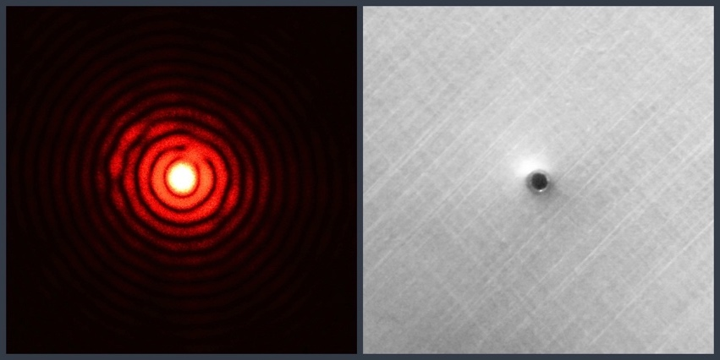

# Theory Part

The part is intended to provide a rudimentary basis for the experiment carried out above. It should only give a rough idea of light as a wave and the possibility to record it in a hologram. A detailed explanation can be found in the known sources on the net (Wikipedia is always a good start!).

What is light?

One always hears that light has both particles (photons) and wave character (e.g. direction of propagation = light rays). Holography is mainly based on the wave character of light. Unlike in photography, where the detectors always measure intensities, in holography we can reconstruct the wave, i.e. the complex amplitude (amplitude and phase). But what exactly does that mean? The light emitted by an LED, for example, is distributed in all directions. Each light beam is the origin of a single light wave with a certain wavelength. Similar to a guitar side, where certain wavelengths can oscillate and the acoustic (longditudinal) waves pass through space to the ear, the light waves move in space. One can imagine the wave as a sinusoidal oscillation, which has a certain amplitude (value at a time and a place) to a certain place in space. If one shifts this sine wave back and forth and compares it to an unshifted wave, one speaks of a phase difference. This phase difference is not visible to the eye. Apart from the fact that it is only a few nanometers (visible light approx. 400-750 nm), the eye and all previous detectors (e.g. cameras) sum up the light. They integrate it because they are simply too slow.

However, a hologram can record this difference. In music, a phase shift can also be made "visible" or audible. A well tuned and a slightly out of tune guitar both play an A. What you hear is the sum of the two frequencies - in this case called beat. The phase is coded. It works the same with the light. You let waves (transversal) interfere with each other in one place. This is often referred to as coherence, which describes nothing other than the interference capability of light. There is constructive and destructive interference, whereby the constructive wave crests (the maxima of the infinitely extended sinusoidal oscillation) reinforce each other. In destructive interference they cancel each other out. This can be seen in the following figure:



## What is coherence?

As mentioned above, coherence describes the interference capability of light. First of all, waves always interfere with each other. The voluemen (both temporal and spatial) in which this happens then gives a statement about how large or small the spatial or temporal interference is.

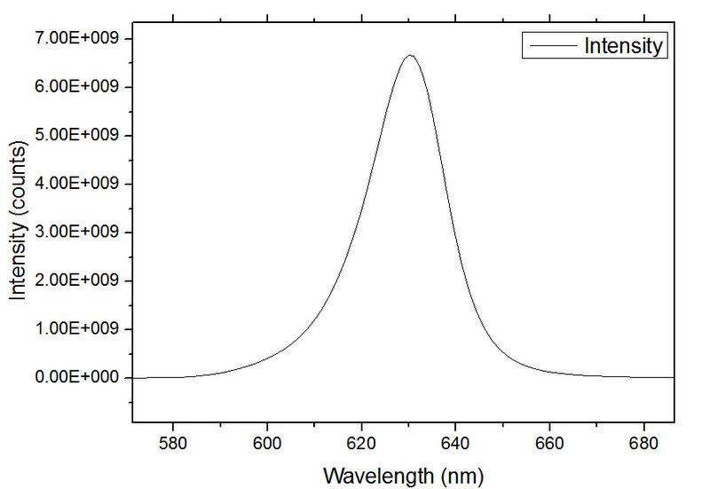 The Michelson interferometer is the best example to explain temporal interference. Mine has a light beam (e.g. laser beam) that hits a beam splitter. The beam splitter splits the beam in equal parts, where both beams meet a mirror, which reflects the light directly back onto the beam splitter. The part that does not return to the beam source can be brought to interference on a screen. The two parts are designated A1 and A2. The optical path that both beams travel determines whether the light beams are in phase and can thus interfere with each other on the screen. A monochrome, narrow-band (only one wavelength) light source has a high temporal coherence. This means that one of the two arms of the interferometer can be moved far and still see an interference pattern, namely the sum of A1+A2. This is only half true, because the sum has to be squared - since we only observe intensities again. This deletes the phase information. The phase information is nevertheless contained in the interference pattern. Our first hologram. If the light source is not monochromatic, but emits many different colors - like e.g. our LED, then not only sine waves with one frequency (wavelength) are superimposed, but many sine waves with many different wavelengths (spectrum of a light source is shown in the graph). The coherence volume sings. The LED thus has a relatively low temporal coherence, but can be increased, for example, by color filters.

The so-called Young's double slit experiment is the best experiment to visualize the spatial coherence. One has an (extended) light source with an aperture with two holes directly behind it. With a certain distance behind the aperture, a screen is placed on which the interference pattern is observed, which produces the two waves coming out of the holes. The smaller the extended light source, the greater the spatial coherence. Our Led - although relatively small - has a relatively small spatial coherence, which we can increase. On the one hand, this is achieved by filtering using pinholes. On the other hand, we can further scale the pinhole, i.e. reduce it in size, by further increasing the distance between the pinhole and the detector. The aperture (and thus also the spatial coherence) "scales" with the ratio $M=\frac{z}{Z}$, where z is the distance from the sensor to the sample and Z is the distance from the source to the sensor. This is visualized in the graphic below.

Thus:

* **Object** as **close as possible** to the chip (3-10mm)
* **Light source** **as far away as possible** from detector (80mm)

Beispiel:

$l_{coh} = \frac{z⋅λ}{2⋅D}$

$l_{coh} = \frac{80mm⋅650nm}{2⋅100µm}$

$l_{coh} ≈0.5-1mm$

Wenn

$Z≫z: D_{phinhole_{wirk}}=\frac{z}{Z}⋅D_{real}$

${→l}_{coh} ≈5-20mm$

Interferenzbedingung:

$$2a<\frac{λ_{0}z}{D}$$

$$a$$

Objekt

Sensor

$$l_{coh}$$

Sensor

$$a$$

Objekt

$$l_{coh}$$

## Holography

### Fundamentals

Here we give only a small impression of what holography really can do. The Wikipedia entry or books like"Coherent Optics: Fundamentals and Applications" by Thomas Kurz provide a first deeper insight. 

Figure 2 Holograms in everyday life; Certificates of authenticity, moisture detectors in the battery or pseudo holograms in concert

A hologram differs fundamentally from a photograph in that it is not the intensity but the field strength (amplitude) that is recorded indirectly via interference. This means that we record the information of the shape of a wave (e.g. spherical wave), which is lost in classical photography. It is often said that holograms take a 3D image or that every small part of a hologram contains all the information of the object being photographed. That's only half the story. In fact, a hologram stores the projection of 3D information, i.e. it adds up the phase information of the object along the propagation direction of the light. This results in a 2.5D image, where each partial hologram - if you cut a large one - actually contains the interference from all object points with the reference wave, but the whole object cannot be reconstructed from it. The information is masked with a window function.

### RECORDING

#### A hologram can be recorded either analog (photo film) or digital (camera sensor). In the analog case it is possible to write both amplitude (silver iodide film) and phase holograms (photosensitive polymers). In the case of the camera chip, intensities are always stored, since there are still no sufficiently fast photosensitive electronics that can measure the phase of the light.

#### To record a hologram there are many different structures. In principle it is always a matter of recording the interference of two light waves (object and reference) and making the object wave available digitally or analogously in the reconstruction in order to generate the object wave. In principle one can distinguish between on-axis (in-line - as here in the experiment) and off-axis holograms.

#### Off-Axis Holography

The reference wave and the object wave hit the detector at an angle. This leads to a better separation of the two information in the frequency space.



The hologram is always created by superimposing two field strengths (reference/object, R and O). The detector measures the intensity, resulting in a large number of different terms. This explains, for example, the orthoscopic and pseudoscopic image, which in the reconstruction creates both a reeles and a virtual image (as with a negative lens) in front of and behind the screen.

The reconstruction is then done by illuminating the hologram with the reference wave (e.g. flat wave under certain angles). This can be expressed mathematically:



Or in experiments:



Figure Aufnahme



Figure 2 Rekonstruktion

#### In-Line Holography

In the case of an in-line image, the object stands directly in a line between the light source and the detector. You can imagine that the object casts something like a shadow, making reconstruction difficult. More precisely, the defocused virtual image is in the same place as the focused real image. This makes it blurry. But you can handle that with appropriate algorithms. The structure - also used in the experiment here - then looks like this:

(kohärente) Lichtquelle

- LED, Laser

z

Pinhole/LWL

Objekt

z

Z

Sensor -> Interferenz:

Objekt-, Referenzwelle

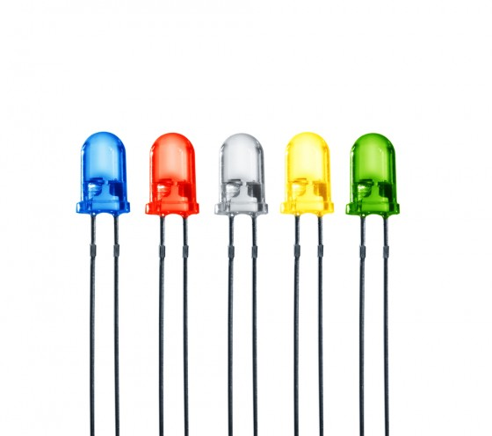

O-Welle

R-Welle

$$T(x,y)$$

$$I(x,y)$$

Orthoskopisches Bild

Pseudoskopisches Bild

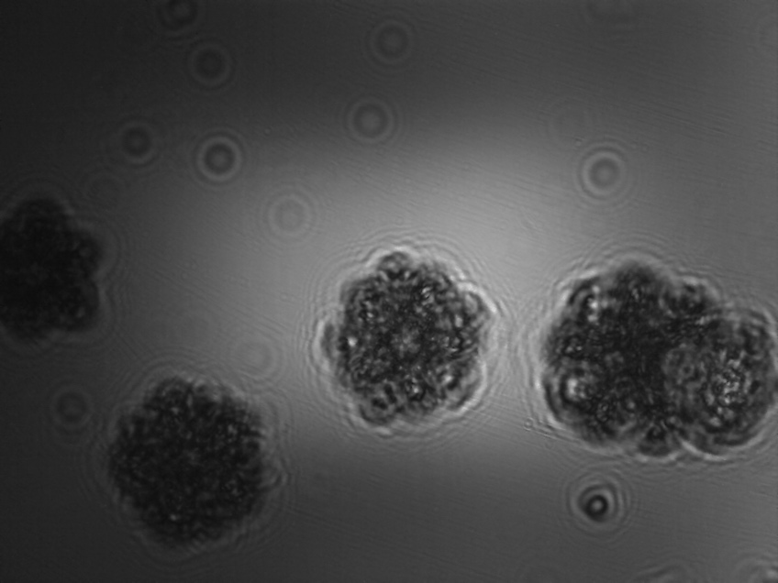

A special case of an experiment is the so-called zone plate, where a point interferes in-line with a plane wave:



Whereby the corresponding reconstruction, i.e. the illumination of the hologram (far right) with a plane wave, leads to the said orthoscopic, pseudoscopic images:

Each object can be assumed to be a sum of infinitely many points, which makes the further step to a hologram of each object easy. One merely superimposes the different zone plates and has at the end an interference pattern corresponding to the object:

In three-dimensional space it looks like this. It should be noted here that this is only successful with samples where multiple scattering is negligible. However, certain methods now allow this as well:



**Numerical reconstruction**

We have already learned that the hologram can be recorded both on an analog medium (film) and on a digital screen (camera sensor). With the camera sensor it is important to ensure that it scans the light field discretely, i.e. that every pixel with a certain size (pixel size) scans the field discretely. There is therefore a finite number of measured values, with a finite depth of possible measured values (e.g. 8Bit = 256 gray scales). 

#### In signal theory it is extremely important to keep a correct "sampling". This means that the signal to be measured must be sampled with at least twice the highest expected frequency. The resulting criterion is the so-called Nyquist-Shannon criterion and plays an important role especially in later processing with the discrete Fourier transform. In the figure above it can be easily illustrated that the sine wave can never be reconstructed with the scanning (black dots). If, however, the double frequency of the sinusoidal oscillation were sampled, all details could be reconstructed. This error is often referred to as aliasing.

#### Fouriertransformation

We only want to give here a basic one of what a clever Frenchman once thought about. The principle is simple and is carried out by the human ear in every single moment. A Fourier decomposition is first of all a decomposition of a continuous signal (e.g. sound) into a sum of weighted frequency components. If we have a perfect guitar with a string and make it vibrate, the result is only a resonance frequency. Thus a tone or a frequency. The easiest way to hear this is to hear the dial tone on the telephone. Perfect 440 heart (heart=vibrations per second). However, a real guitar does not only have one frequency with which it vibrates, but always many. The higher harmonic oscillations still resonate - all integer multiples of frequencies that can also be placed on a string. A string is a resonator on which integer frequencies of the possible wavelength (depending on the length and tension of the string) can be mapped. If we make the string vibrate, we can no longer distinguish the different frequencies from each other, as they overlap and propagate to the receiver (e.g. the ear). The ear in turn decomposes these frequencies by a clever mechanism. The superposition of the oscillations reaches the inside of the ear via the earcup, where small hairs, each with its own resonance frequency, vibrate and "decompose" the different frequencies. This frequency can be found not only in the sound/sound, but also in the room/image. A periodic structure (e.g. a grid) can also be decomposed into its Fourier components/frequency components. The FFT (Fast Fourier Transform) does nothing else.



#### Fourierfilterung

But why all the effort with the Fourier transformation? In optics, the Fourier decomposition is often encountered, especially because a lens performs this transformation instantaneously. Something in the focal length of the lens automatically undergoes a Fourier transformation when passing an ideal (thin) lens.

This is clear if one imagines the sun, which is (almost) infinitely far away from the earth. The emitted light rays are almost parallel and form a quasi flat wave front. A lens focuses this parallel beam in the focal point, which is equivalent to a Fourier transformation, since the Fourier transformation of an infinitely small point corresponds to a constant (plane). The lens takes over another task. Since it is not infinitely extended, it limits the information bandwidth - it filters the light:



The above figure can easily be demonstrated in an experiment. A laser is directed at a CD/DVD. The light is diffracted by the structure and should then be imaged by the lenses 1 and 2. The aperture shown represents the so-called pupil function, which filters the imaged light. This is simply because the lens is grasped mechanically and all rays that do not pass through the mechanical opening are blocked. 

For the formation of an image, however, it is absolutely necessary to let at least the first and the zero diffraction order pass. The diffraction orders lead in their intereference to an image, which is not the case in the second graphic, where the blend was closed. The image is gray and provides no contrast.

The angles that result after the grid can be calculated with the simple formula: 

#### Reconstruction of the Hologram

We now use the already explained filtering in the Fourier room to reconstruct the in-line hologram with a corresponding pupil function. If we look at the structure again:



then we see that the LED is first converted from a pinhole (small hole in aluminum foil) to a point light source. This generates more or less clean spherical waves (coming from the right), which then hit the transparent object (left) and generate an in-line hologram (interference of spherical waves with diffracted light of the object) on the Raspi chip. The basic idea to reconstruct the object is very simple. We now want to numerically propagate back the distance from the sensor to the object. We do this with an appropriate phase factor in the pupil or mathematically expressed as:

$H_{f}\left(f_{x},f_{y}\right)=\exp\left(i2πz\right)⋅exp⁡(-iπλz\left(f_{x}^{2}+f_{y}^{2}\right))$

$$U_{2}\left(x,y\right)= I^{-1}\{I\{U_{1}\left(x,y\right\}H_{f}(f_{x},f_{y})\}$$

This is also known as Fresnel propagation. The mathematical function describes a so-called convolution. In practice, this means that we focus each pixel numerically by a certain amount along the optical axis. So we can refocus numerically and propagate the object back into focus:

# APPENDIX

Recording with Raspi camera

#### The camera is a central component of image acquisition. In order to do justice to the basic idea of the easy availability of the devices, we also fall back here on open source solutions.

#### The mini-computer Raspberry Pi is the most sold computer in the world and allows the control of hardware components and complex software. In this workshop we use the camera of the device, which is very easy to operate via the terminal, but also via the Python PiCam interface.

#### Further information can be found here:

#### <https://github.com/rwb27/openflexure_microscope/wiki/Camera-Options>

#### Specifications

#### Resolution: 2464x3280

#### Pixel size: 1.12um

#### Sensor size: 3.67x2.76mm

#### Standard lens (focal length): 3.04mm

### The sensor is very sensitive, the software allows a simple control of the shooting parameters (exposure time, etc.), as well as the storage and output of captured images. The new version (V2.1) is based on a Sony IM135 sensor, which can also be found in mid-range smartphones.

### Please note that the lens must be removed from the camera model. The normally corrected shading correction, which compensates for lens errors, now overcompensates the images, resulting in a bright edge.

### RECORDING HOLOGRAMS

It is important to connect the camera correctly to the Raspberry first. Please note the orientation of the ribbon cable. The power supply, a keyboard+mouse and a monitor should also be connected.

For the recording of holograms the LED must be switched on. Then the Raspbian terminal can be opened. To create an image, enter the following:

**raspistill -f test.jpg -t 10000**

- raspistill is the program that opens the camera.

-f is a flag that displays the image seen on the screen.

- test.jpg is the file name for the information stored in the /home/pi folder.

- t 10000 is another flag which indicates the time of the display (10s or 10000 ms).

Multiple images with different file names can now be captured. Save them on a USB stick and reconstruct them with the FIJI plugin.

Recording with M5Stack Camera

For the recording of the hologram we use the ESP32 which is equipped with a camera (OV2640). For this we have already created a small program which automatically sends the image via WiFi to a computer.

More info here:

<https://github.com/m5stack/M5Stack-UserGuide/blob/master/ESP32CAM.md>

#### Details about the camera:

* + Dual-core Tensilica LX6 microprocessor
  + Bis zu 240MHz clock frequency
  + 520kB internal SRAM
  + 4MB Flash memory
  + Integrierter 802.11 BGN WiFi transceiver
  + Integrierter dual-mode Bluetooth (classic and BLE)
  + Hardware accelerated encryption (AES, SHA2, ECC, RSA-4096)
* CP2104 USB TTL
* OV2640 sensor
  + Output Formats(8-bit):
    - YUV(422/420)/YCbCr422
    - RGB565/555
    - 8-bit compressed data
    - 8-/10-bit Raw RGB data
  + Maximum Image Transfer Rate
    - UXGA/SXGA: 15fps
    - SVGA: 30fps
    - CIF: 60fps
  + Scan Mode: Progressive
* Kamera Spezifikationen:
  + CCD size : 1/4inch
  + Field of View : 78 degree
  + Maxmium Pixel: 200W
* Sensor best resolution: 1600 * 1200
* Abmessungen: 25mm x 24mm
* Gewicht: 5g

### SAMPLE PREPARATION

Mucosal cells, for example, are particularly suitable for imaging because they have only a low amplitude contrast, i.e. the light is only slightly attenuated, but the differences in light pathways lead to beautiful inferences. For this purpose, a clean spoon can be used to remove some cells from the inside of the oral mucosa. If these are given on a microscope slide, the preparation can be sealed with a cover slip.

Other specimens which are excellently suited are shampoos with microplastic particles.

Useful links and sources

* iGEM 2017
* Beniroquai Blog
* Master Thesis Upsalla

Publications

Ayoub, A., Divós, P., Tóth, S., & Tõkés, S. (2006a). Software Algorithm to Reconstruct 2D Images from Recorded 3D In-Line DHM Holograms. *Computer and Automation Research Institute*, 5.

Ayoub, A., Divós, P., Tóth, S., & Tõkés, S. (2006b). Software Algorithm to Reconstruct 2D Images from Recorded 3D In-Line DHM Holograms. *Computer and Automation Research Institute*, 5.

Bishara, W., Su, T.-W., Coskun, A. F., & Ozcan, A. (2010). Lensfree on-chip microscopy over a wide field-of-view using pixel super-resolution. *Optics Express*, *18*(11), 11181–11191. http://doi.org/10.1364/OE.18.011181

Bishara, W., Zhu, H., & Ozcan, A. (2010). Holographic opto-fluidic microscopy. *Optics Express*, *18*(26), 27499–27510. http://doi.org/10.1364/OE.18.027499

Coupling, F., Calculation, E., Copyright, C., & Reserved, A. R. (2007a). APPLICATION NOTE Table of Contents, (418), 1–7.

Coupling, F., Calculation, E., Copyright, C., & Reserved, A. R. (2007b). APPLICATION NOTE Table of Contents, (418), 1–7.

Examples of Digital Hologram Reconstruction Programs. (n.d.).

Garcia, G. E. (2013). Proof-of-concept demonstration of smart optical imaging systems, 2012–2013.

Greenbaum, A., Akbari, N., Feizi, A., Luo, W., & Ozcan, A. (2013a). Field-Portable Pixel Super-Resolution Colour Microscope. *PLoS ONE*, *8*(9), 1–9. http://doi.org/10.1371/journal.pone.0076475

Greenbaum, A., Akbari, N., Feizi, A., Luo, W., & Ozcan, A. (2013b). Field-Portable Pixel Super-Resolution Colour Microscope. *PLoS ONE*, *8*(9), 1–9. http://doi.org/10.1371/journal.pone.0076475

Hardie, R. C., Barnard, K. J., & Armstrong, E. E. (n.d.). Joint MAP Registration and High Resolution Image Estimation Using a Sequence of Undersampled Images 1 List of Figures. *Image (Rochester, N.Y.)*, *12*.

Holography, M. D. (n.d.). Introduction to Modern Digital Holography with MATLAB.

Jenkins, C. (2012). Digital Holography and Applications in Microscopic Interferometry. Retrieved from http://digitalcommons.calpoly.edu/physsp/57/\nhttp://digitalcommons.calpoly.edu/cgi/viewcontent.cgi?article=1057&context=physsp

Poon, T.-C., & Liu, J.-P. (2014). *Introduction to Modern Digital Holography*.

Propagation, B., & Manual, T. (1998). LightPipes for Matlab, (c), 1–113.

Salih, A., & Tahir, K. J. (2013). Digital in-line holography for blood cell, *8*(2), 68–72. http://doi.org/10.5897/IJPS12.663

Schultz, S. M. (2007). Using MATLAB to help teach Fourier optics. *Proc. of SPIE*, *6695*(2), 66950I–66950I–10. http://doi.org/10.1117/12.735889

Seifi, M., Fournier, C., & Denis, L. (2012). HoloRec3D: A free Matlab toolbox for digital holography. Retrieved from http://hal-ujm.ccsd.cnrs.fr/ujm-00749137/

Sha, B., Liu, X., Ge, X.-L., & Guo, C.-S. (2014). Fast reconstruction of off-axis digital holograms based on digital spatial multiplexing. *Optics Express*, *22*(19), 23066. http://doi.org/10.1364/OE.22.023066

Shimobaba, T., Weng, J., Sakurai, T., Okada, N., Nishitsuji, T., Takada, N., … Ito, T. (2012). Computational wave optics library for C++: CWO++ library. *Computer Physics Communications*, *183*(5), 1124–1138. http://doi.org/10.1016/j.cpc.2011.12.027

Shiraki, A., Taniguchi, Y., & Shimobaba, T. (2012). Handheld and low-cost digital holographic microscopy. *Physics Optics*, 1–7.

Simpkins, J., & Stevenson, R. L. (2012). An Introduction to Super-Resolution Imaging.

Verrier, N., Atlan, M., Verrier, N., & Atlan, M. (2011). Off-axis digital hologram reconstruction : some practical considerations To cite this version : considerations.

Kanka, M., Riesenberg, R., Petruck, P., & Graulig, C. (2011). High resolution (NA=08) in lensless in-line holographic microscopy with glass sample carriers. *Optics Letters*, *36*(18), 3651. http://doi.org/10.1364/OL.36.003651

Kirchmann, C. C. (2014). A Study of Digital In-Line Holographic Microscopy for Malaria Detection Elin Lundin A Study of Digital In-Line Holographic Microscopy for.

Latychevskaia, T., & Fink, H. (n.d.). Practical algorithms for simulation and reconstruction of digital in-line holograms, 1–23.

Latychevskaia, T., & Fink, H.-W. (2013). Resolution enhancement in digital holography by self-extrapolation of holograms. *Optics Express*, *21*(6), 7726–33. http://doi.org/10.1364/OE.21.007726

Lee, H., Xu, L., Koh, D., Nyayapathi, N., & Oh, K. (2014). Various On-Chip Sensors with Microfluidics for Biological Applications. *Sensors*, *14*(9), 17008–17036. http://doi.org/10.3390/s140917008

Luo, W., Greenbaum, A., & Zhang, Y. (2015). Accepted Article Preview : Published ahead of advance online publication, (August 2014). http://doi.org/10.1038/lsa.2015.34.This

Manuscript, A. (2012a). NIH Public Access. *Changes*, *29*(6), 997–1003. http://doi.org/10.1016/j.biotechadv.2011.08.021.Secreted

Manuscript, A. (2012b). NIH Public Access. *Changes*, *29*(6), 997–1003. http://doi.org/10.1016/j.biotechadv.2011.08.021.Secreted

Manuscript, A., & Imaging, O. B. (2013). NIH Public Access, (c), 29–46. http://doi.org/10.1109/RBME.2012.2215847.On-Chip

Molony, K. M., Hennelly, B. M., Kelly, D. P., & Naughton, T. J. (2010). Reconstruction algorithms applied to in-line Gabor digital holographic microscopy. *Optics Communications*, *283*(6), 903–909. http://doi.org/10.1016/j.optcom.2009.11.012

Mudanyali, O., Tseng, D., Oh, C., Isikman, S. O., Sencan, I., Bishara, W., … Ozcan, A. (2010). Compact, light-weight and cost-effective microscope based on lensless incoherent holography for telemedicine applications. *Lab on a Chip*, *10*(11), 1417–1428. http://doi.org/10.1039/c000453g

No Title. (2010).

*Optical Scanning Holography With Matlab ® Optical Scanning Holography With Matlab ®*. (n.d.). *Computer*.

Pandey, N. (2011). Digital hologram recording systems : some performance improvements.

Park, S. C., Park, M. K., & Kang, M. G. (2003). Super-resolution image reconstruction: A technical overview. *IEEE Signal Processing Magazine*, *20*(3), 21–36. http://doi.org/10.1109/MSP.2003.1203207

## Hilfreiche Links

* <https://www.jpl.nasa.gov/edu/learn/project/how-to-make-a-pinhole-camera/>
* <http://pinholemoustache.com/wp-content/uploads/2015/09/2c-cu-acul-cu-grija-stenopa.jpg>